The artifact that I made enhancements on was my Inventory management application that I created for my CS 360 Mobile Architect & Programming course that I completed in June 2025. The purpose of the application was to provide a way for warehouse associates to manage and track the warehouse’s inventory. This artifact will be used for all three categories, so I will be rebuilding my entire application to be operational and flawless. For this submission, the application is functioning to showcase my data structure. I will be submitting my old application and my in-progress application for the enhanced application for this module, but the application will still be incomplete until the third enhancement which is incorporating a new database. In general, I chose this artifact because it was the only course that I didn’t deliver a functional program, so I wanted to prove to myself that I can complete and improve the app. I chose this artifact to include in my ePortfolio because of the current job market and to showcase my programming skills using the language Java. I have seen plenty of openings that are looking for developers that are proficient in Java and openings for android development as well. This will also demonstrate my ability to work with different data structures as well as using them together.
The specific components that showcase my skills and abilities in this enhancement is my understanding how to bridge data and the UI with an adapter, transforming raw data, and processing data efficiently. I improved this artifact by implementing a HashMap data structure to replace the ArrayList data structure from my old inventory app. One reason I decided to use HashMap was because of its ability to map values to unique IDs, which would be extremely useful for an inventory application. Due to its time complexity being O(1) it’s faster than ArrayList for searching, adding, and deleting. Another reason I chose to implement a HashMap instead of ArrayList was to receive more practice with using it. For this enhancement, the course outcome that I planned to meet in Module one was to design and evaluate computing solutions that solve a given problem using algorithmic principles and computer science practices and standards appropriate to its solution while managing the trade-offs involved in design choices. I believe I met this outcome by implementing HashMap. I plan on updating the UI for a more cohesive and appealing appearance. This was just to show that it functions properly.
The process of enhancing and modifying this portion of the artifact was a little more difficult than I thought it would be. My emulator kept terminating, but the logcat assisted when that occurred, which was very helpful. Another challenge that I had was my search method not returning the search, but I corrected that. I learned how to correctly implement a Recycler View, one of the main components I struggled with in the original application. I learned how to incorporate layout views inside the source code instead of trying to use it in the layout xml. It made it easier to use the HashMap functions along with alert dialogs. I also learned how to incorporate the ability to use the “Enter Key” after typing.

SEARCH by SKU

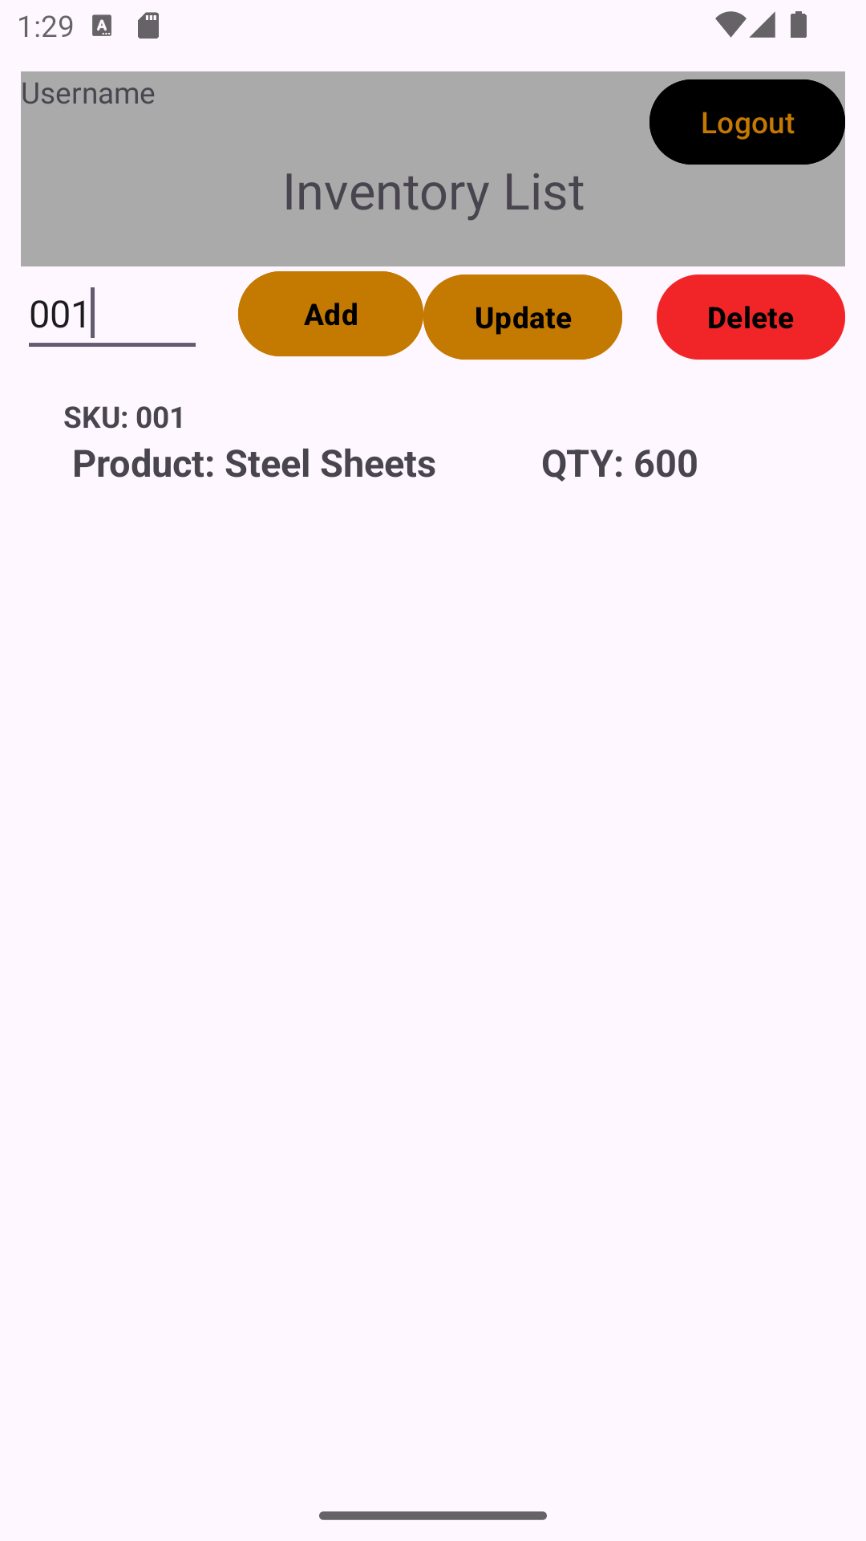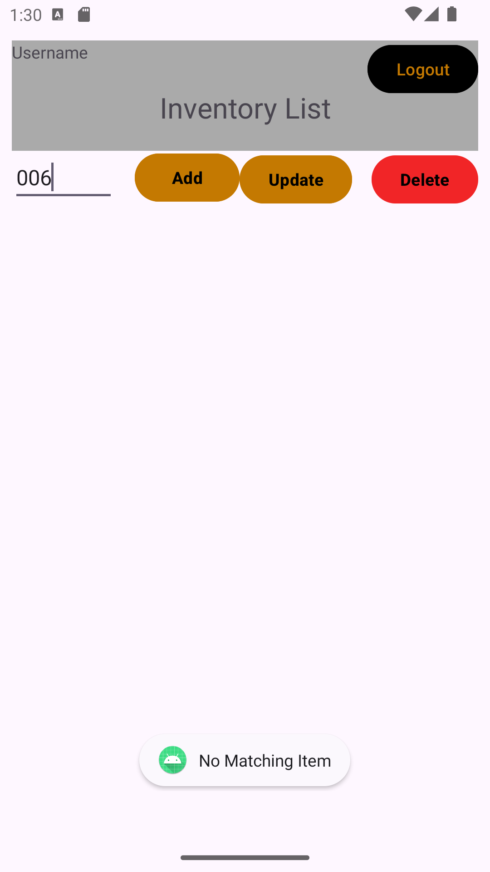

UPDATE product
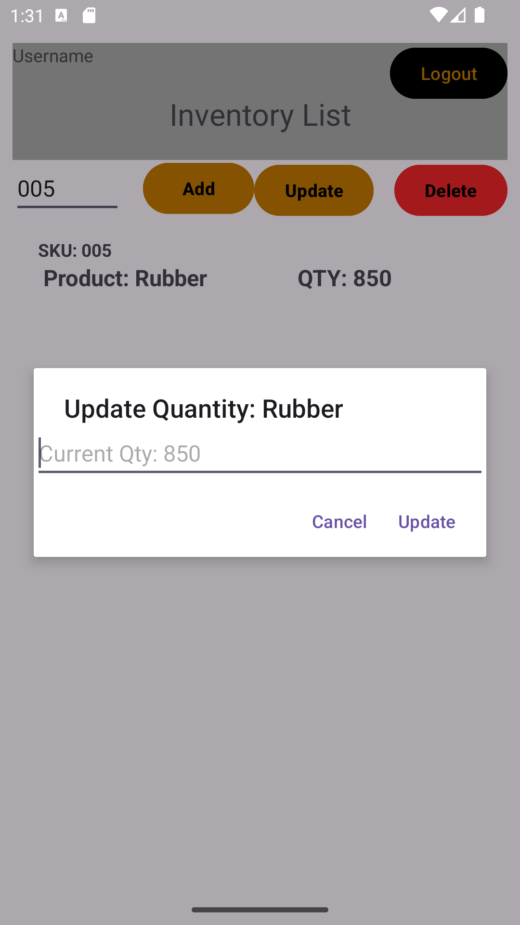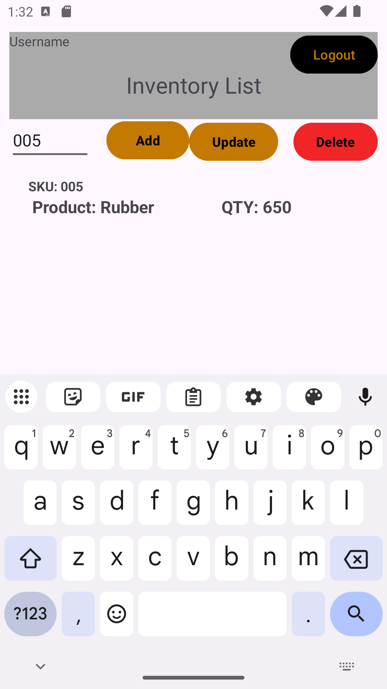

ADD product
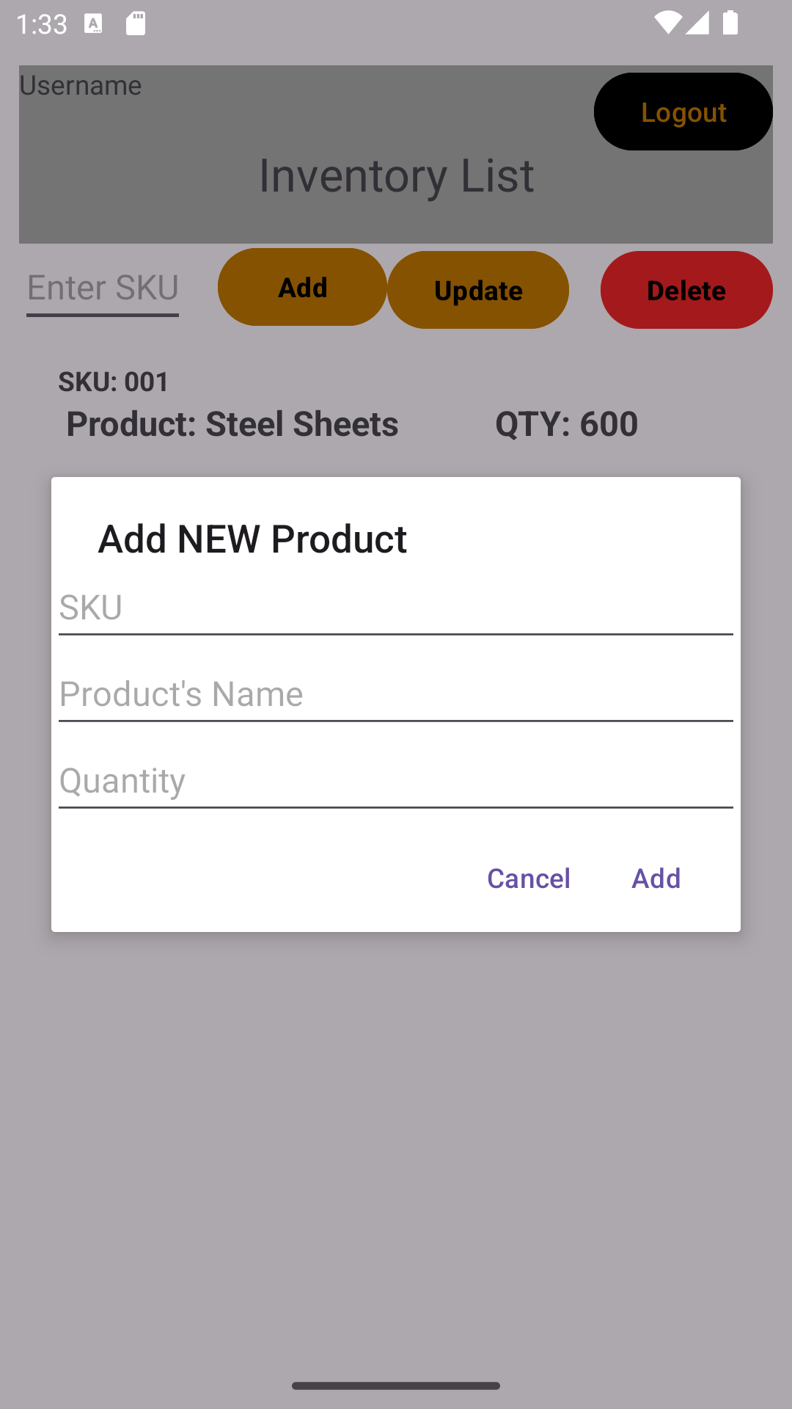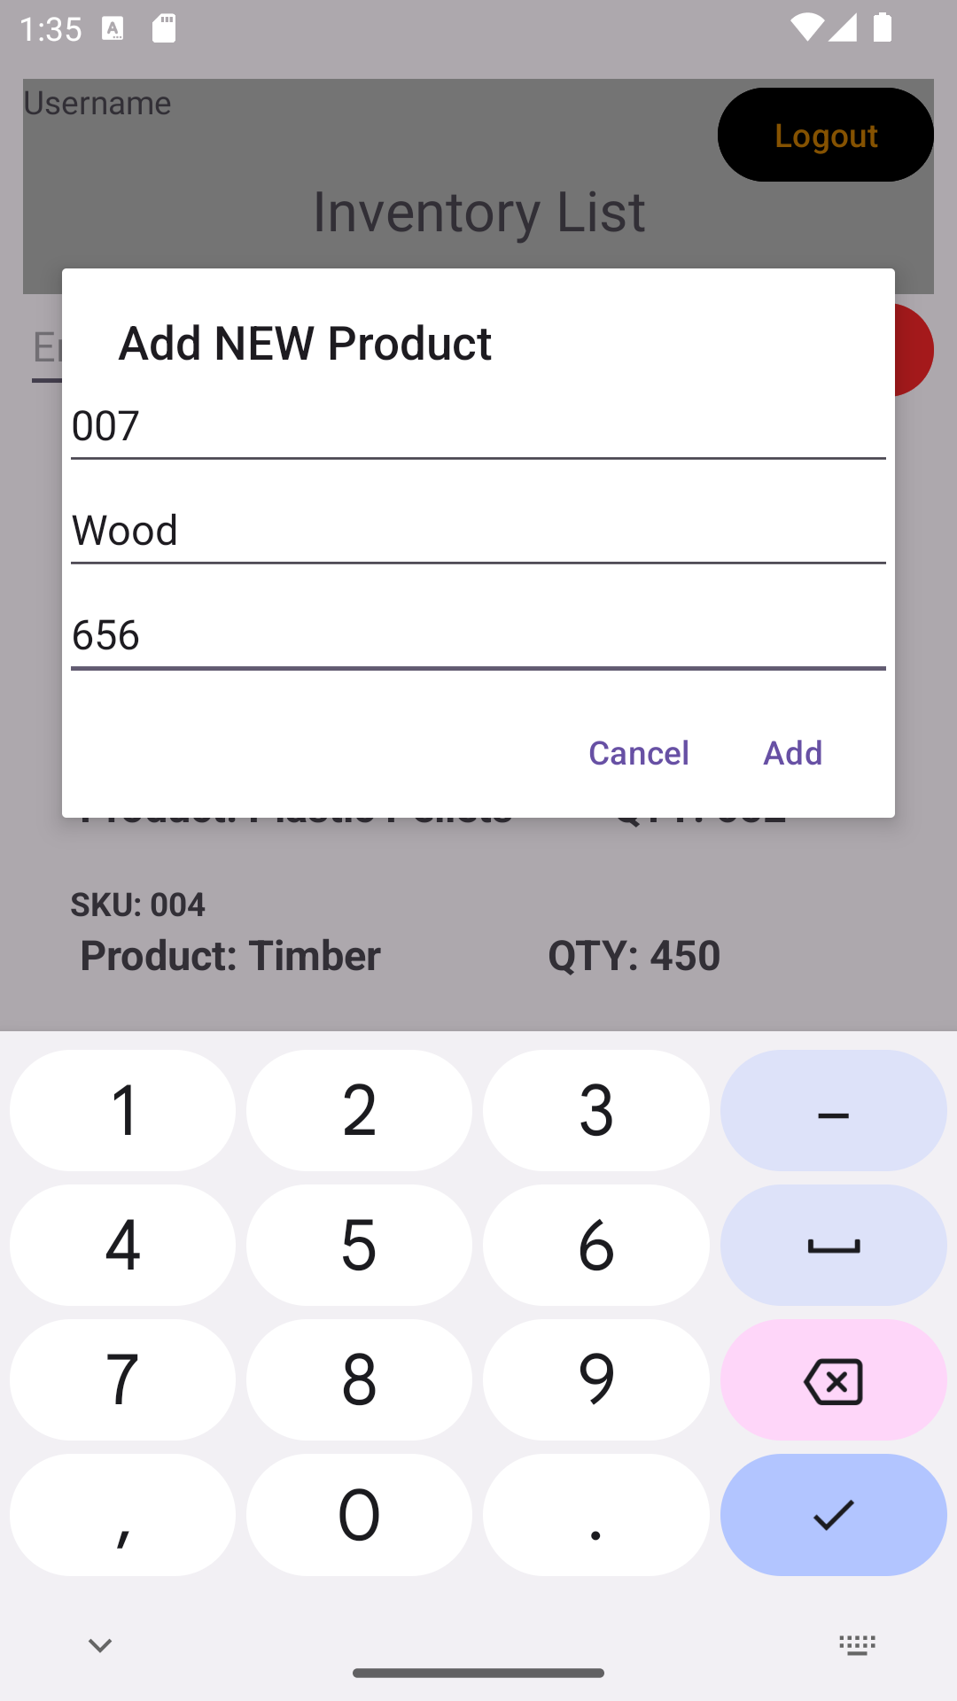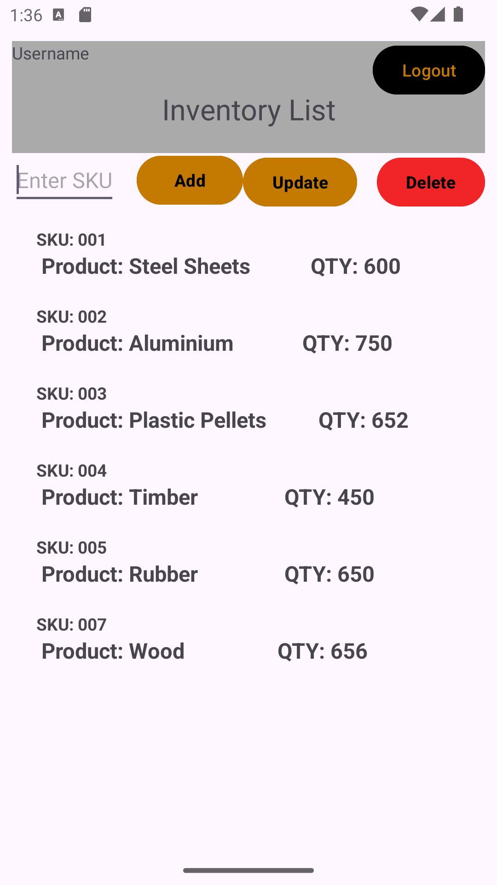

DELETE by SKU
